St Andrew’s Church
Orford with Longford
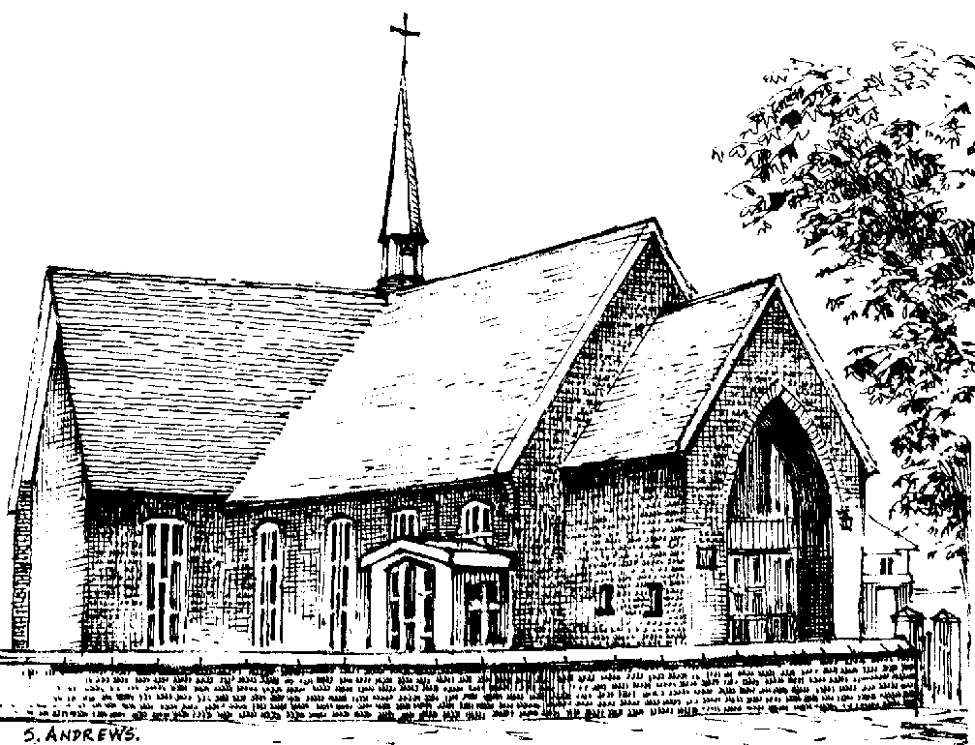

Harry Jones

1931 - 2012

Friday 12th October 2012

Introduction

All: Merciful Father, hear our prayers and comfort us; renew our trust in your Son, whom you raised from the dead; strengthen our faith that all who have died in the love of Christ will share in his resurrection; who lives and reigns with you, in the unity of the Holy Spirit, one God, now and for ever. Amen

Hymn: “Guide me O thou Great redeemer”

Guide me, O thou great Redeemer,
pilgrim through this barren land;
I am weak, but thou art mighty;
hold me with thy powerful hand:
bread of heaven,
feed me now and evermore.

Open now the crystal fountain
whence the healing stream doth flow;
let the fiery cloudy pillar
lead me all my journey through;
strong deliverer,
be thou still my strength and shield.

When I tread the verge of Jordan,
bid my anxious fears subside;
death of death, and hells destruction,
land me safe on Canaan's side:
songs and praises
I will ever give to thee.

The Ministry of the Word

The Scriptural Reading (1 Peter 1. 3-9)

At the end of the reading:

This is the word of the Lord
All: Thanks be to God

Hymn: On a hill far away stood an old rugged cross,
The emblem of suff'ring and shame;
and I love that old cross where the dearest and best
For a world of lost sinners was slain.
So I'll cherish the old rugged cross
Till my trophies at last I lay down;
I will cling to the old rugged cross
And exchange it some day for a crown.

Oh, the old rugged cross, so despised by the world,
Has a wondrous attraction for me;
For the dear Lamb of God left his glory above
To bear it to dark Calvary.
So I'll cherish the old rugged cross

In the old rugged cross, stained with blood so divine,
A wondrous beauty I see;
For 'twas on that old cross Jesus suffered and died
To pardon and sanctify me.
So I'll cherish the old rugged cross

To the old rugged cross I will ever be true,
Its shame and reproach gladly bear;
Then He'll call me some day to my home far away,
Where his glory for ever I'll share.
So I'll cherish the old rugged cross

The Address

A Reflection: “You’re my best friend” – Foster and Allen

The Prayers:

Each section concludes:
Lord, in your mercy
All: hear our prayer.

After the final section:
God of mercy, entrusting into your hands all that you have made and rejoicing in our communion with all your faithful people, we make our prayers through Jesus Christ our Saviour. Amen.
The Lord’s Prayer

Hymn: “What a friend we have in Jesus”

All our sins and grief to bear!
What a privilege to carry
Everything to God in prayer!
Oh, what peace we often forfeit.
Oh, what needless pain we bear.
All because we do not carry
Everything to God in prayer.

Have we trials and temptations?
Is there trouble anywhere?
We should never be discouraged;
Take it to the Lord in prayer.
Can we find a friend so faithful
Who will all our sorrows share?
Jesus knows our every weakness;
Take it to the Lord in prayer.

Are we weak and heavy-laden,
Cumbered with a load of care?
Precious Saviour, still our refuge –
Take it to the Lord in prayer.
Do they friends despise, forsake thee?
Take it to the Lord in prayer:
In his arms he’ll take and shield thee,
Thou wilt find a solace there.

Commendation and Farewell

All: Heavenly Father, in your Son Jesus Christ you have given us a true faith and a sure hope. Strengthen this faith and hope in us all our days, that we may live as those who believe in the communion of saints, the forgiveness of sins and the resurrection to eternal life; through Jesus Christ our Lord. Amen.

Acknowledgement: Common Worship: Pastoral Services, material from which is included in this service, is copyright © The Archbishops’ Council (2000)

